Game Hardware 3

CA Project

Submitted by Liam Ross (A00282639)

**Detections:**

Face and Eye Detection

Classifiers Used: haarcascade_frontalface_default.xml & haarcascade_eye.xml

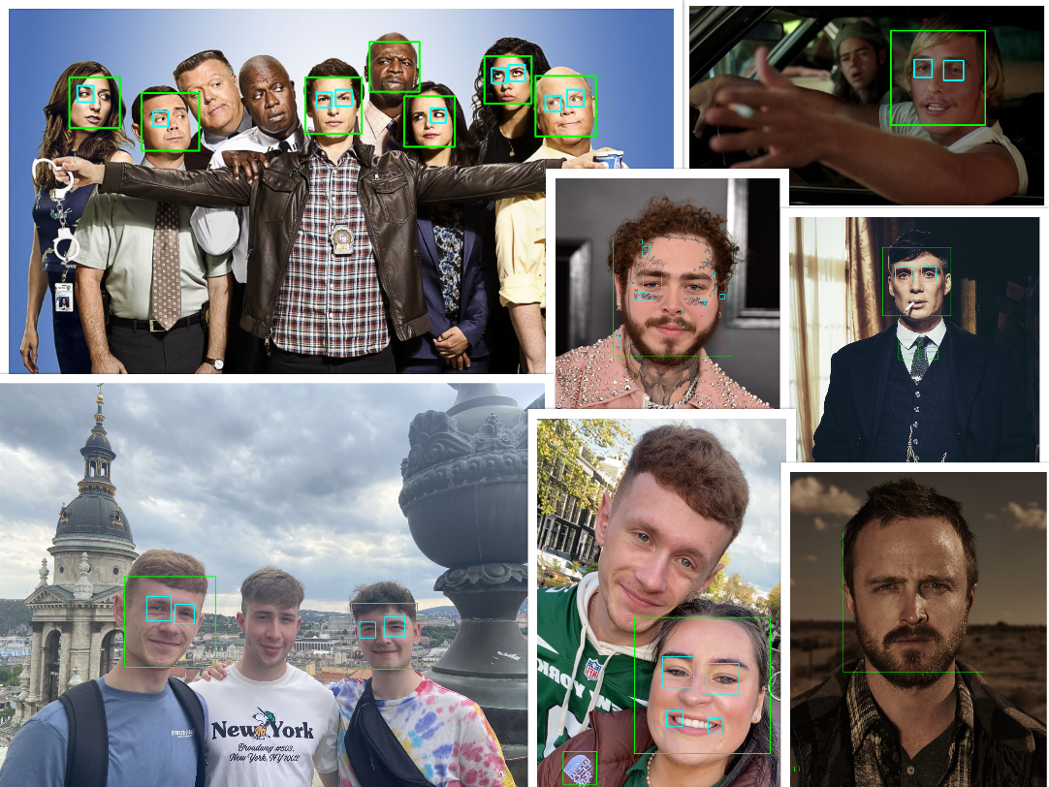

Classifiers Used: lbpcascade_frontalface_improved.xml & haarcascade_eye.xml

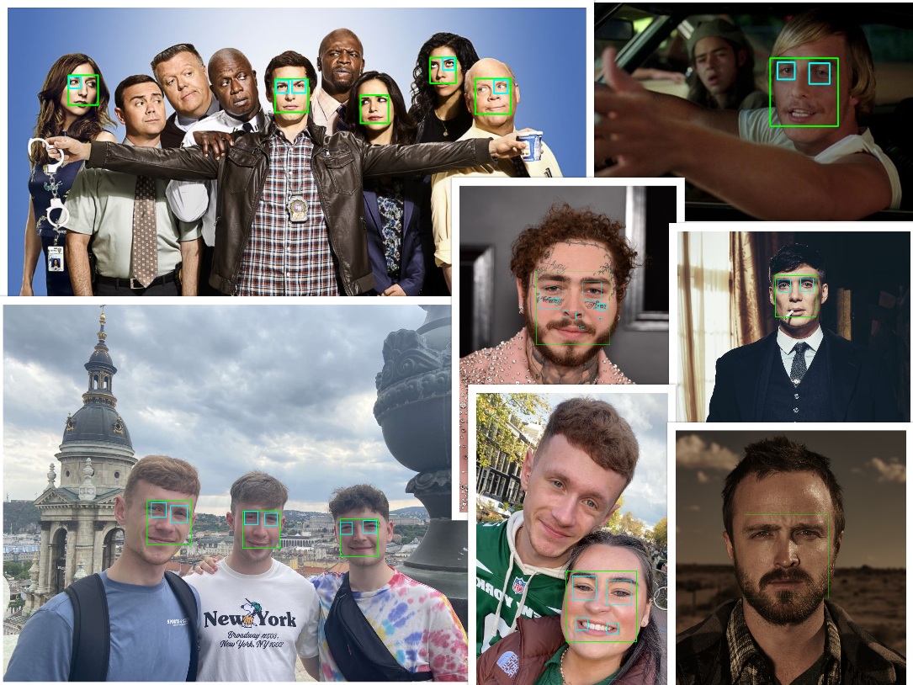

Face and Smile Detection

Classifiers Used: lbpcascade_frontalface_improved.xml & haarcascade_smile.xml

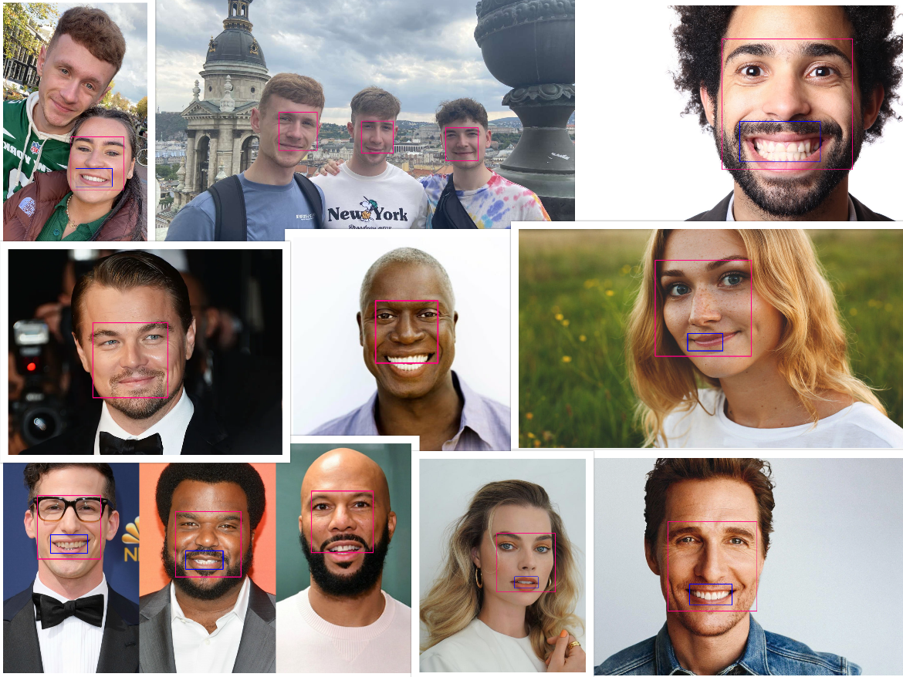

Number Plate Detection

Classifiers Used haarcascade_russian_plate_number.xml

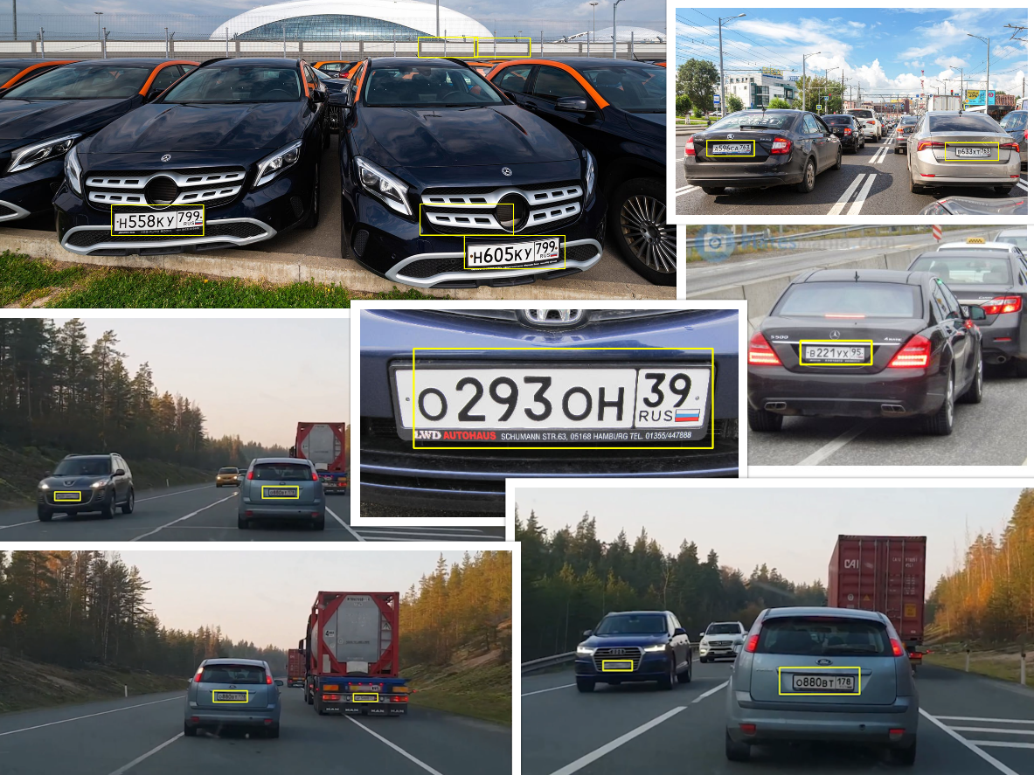

Car Detection

Using haarcascade_car.xml

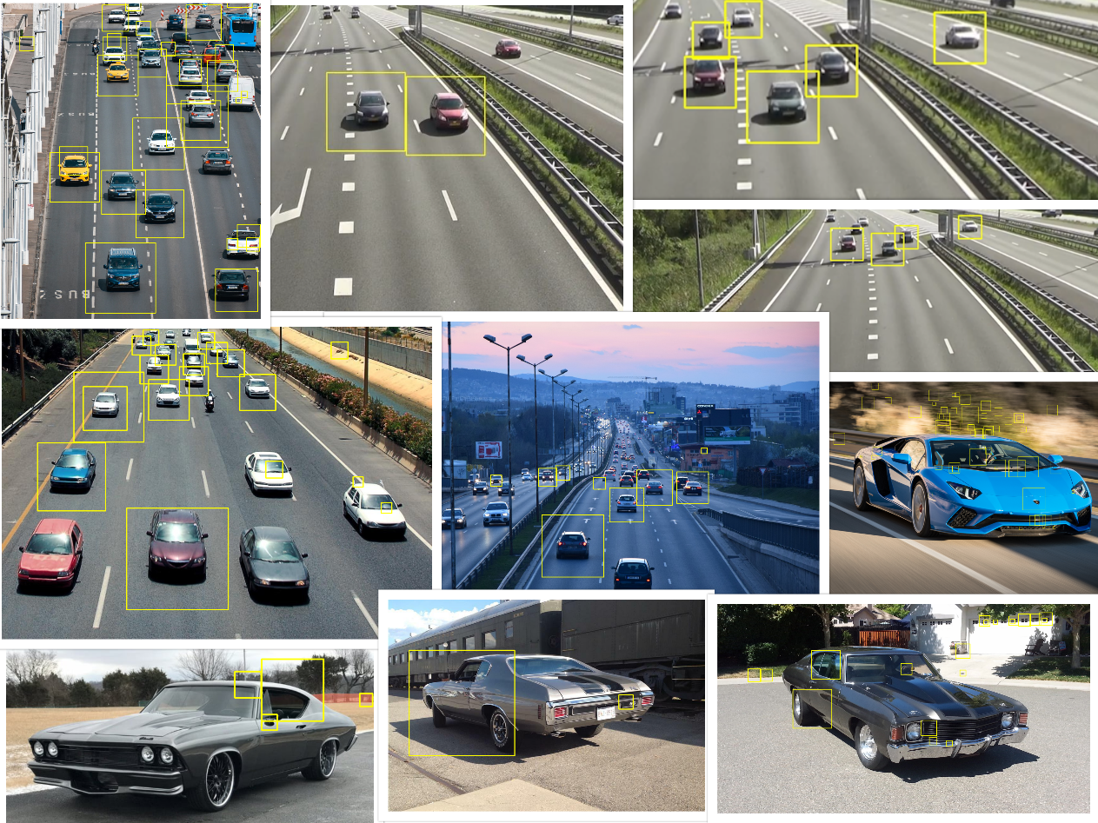

**Report**

Blah

**Software Used:**

OS:

* macOS Monterey – Version 12.4

Python:

* Version: 3.10

Packages:

* OpenCV – Version: 4.6.0.66
* Numpy – Version: 1.23.5

Environment

* PyCharm IDE – Version 2022.2.4

Classifiers:

* haarcascade_russian_plate_number.xml
* haarcascade_car.xml
* haarcascade_frontalface_default.xml
* lbpcascade_frontalface_improved.xml
* haarcasade_smile.xml
* haarcascade_eye.xml
* cars.xml

Python Source Code:

* Found in *whatever directory*

**References:**

**Images:**

cars.jpeg: <https://pixabay.com/photos/highway-city-cars-traffic-road-7213206/>

cars1.jpeg: <https://driversed.com/trending/the-best-defense-preparing-to-share-the-road-with-self-driving-cars>

chevelle70.jpg: <https://www.barrett-jackson.com/Events/Event/Details/1970-CHEVROLET-CHEVELLE-SS-454-180621>

chevelle68.jpg: <https://www.mecum.com/lots/SC0519-371993/1968-chevrolet-chevelle/>

chevelle71.jpg: <https://www.mecum.com/lots/CA0814-190004/1971-chevrolet-chevelle-heavy-chevy/>

b991.jpg: <https://www.tvinsider.com/949404/brooklyn-nine-nine-police-brutality-season-8-storyline/>

post.jpg: <https://www.pinterest.ie/pin/389631805266435293/?amp_client_id=CLIENT_ID%28_%29&mweb_unauth_id=&amp_url=https%3A%2F%2Fwww.pinterest.com%2Famp%2Fpin%2F389631805266435293%2F&amp_expand=true>

tommy.jpg: <https://nyla-hurst.blogspot.com/2021/04/tommy-shelby-peaky-blinders-wallpaper.html>

dazed3.jpg: <https://wallpapercave.com/dazed-and-confused-desktop-wallpapers>

smileWoman.jpg: <https://www.healthline.com/health/types-of-smiles>

smileMan.jpg: <https://www.plowzandmowz.com/smiling-man/>

leo.png: <https://www.self.com/story/leonardo-dicaprio-is-the-internets-most-beloved-actor>

matthew.png: <https://wallpapercave.com/matthew-mcconaughey-wallpapers>

numberPlate.jpg: <https://licenseplatemania.com/landenpaginas/rusland.htm>

numberPlate1.jpg: <https://platesmania.com/ru/nomer11962743>

numberPlate2.jpg: <https://www.roadpol.eu/index.php/numbers-reveal-illegal-russian-licence-plates>

numberPlate3.jpg: <https://www.rbth.com/lifestyle/334097-russian-license-plates>

**Videos:**

cars.mp4: <https://pixabay.com/videos/traffic-car-highway-street-27260/>

numberPlateVid.mp4: <https://www.youtube.com/watch?v=18f3-Znp32I>

**Classifiers:**

Haarcascade xml files sourced from: <https://github.com/opencv/opencv/tree/master/data/haarcascades>

lbpcascade_frontalface_improved.xml: <https://github.com/shamangary/SSR-Net/blob/master/demo/lbpcascade_frontalface_improved.xml>